**Star Wars Russian Roulette Project**

First I started with a simple design with a background image, five buttons, 3 picture boxes and a scoring box so I could make everything fit together easier then work my way high with the design.

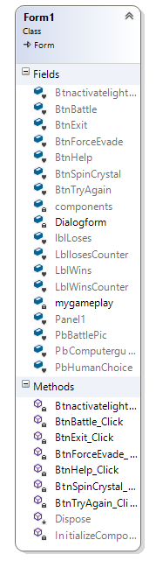The random number generator had to be the many heart of the design first so my priority was to get that working, Which was tricky at first because I had it under the button click event then had to change it and place it in the class (Gameplay) because I forgot about not being able to have variables in my main form.

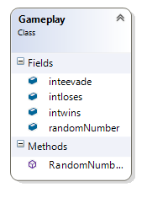

Once the number generator was working the way I had wanted, I made the second chance button (Force Evade) with a shared function in in my class (gameplay) so it was shared to the main form so it would count to two then make the button disabled along with each button click it would minus a number from the random number generator (skipping a shot fired/chance of dying).

Under the main button (battle) it was pretty simple to place a counter that minuses the random number by one each click, then putting a select case method in so each number from (1-6) had a result and picture i.e.: One was of course the death case as the counter counts down to one randomly, the other five were blank cases (no shot fired).

Once all that was working I made another button called “Help” which I added a second form to appear when clicked to give a basic run down on how to play, which involved a button and some labels for the rules.

Then the other two buttons “Exit” and “Try Again” pretty straight forward, exit just uses (me.close) and try again uses (controls.clear() & InitializeComponent()).

So once that all finally worked the program was fully functional being able to activate the (light saber) which loaded the light saber then click (spin light saber crystal) to generator the random number then clicking the battle to button to start the game also being able to use (force evade) to try and avoid losing.